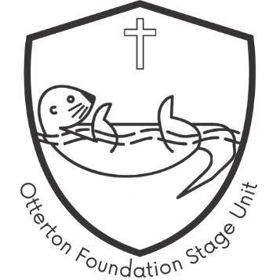
Otterton Foundation Stage Unit
Application Form

Personal details:
First name(s) of child:

Surname of child: |  | Date of birth:
Full address:
 |  | Postcode:

Parent/Carer Details:
Name

Relationship to child

Full address (if different):
 |  | Postcode:
Telephone number: |  | Alternative telephone:
E-mail address:

Session Details
We are open Monday to Wednesday 9.00am until 3.00pm. Our sessions are Morning – 9.00am to 12.00pm and All day 9.00am to 3.00pm. For lunchtime sessions you will need to provide a packed lunch for your child or order a school dinner through the office.
Preferred Start Date
Monday |  |  | Tuesday |  | Wednesday
Morning  9.00-12.00 | All Day  9.00-3.00 |  | Morning  9.00-12.00 | All Day  9.00-3.00 | Morning  9.00-12.00 | All Day  9.00-3.00

Funding
My child is entitled to 15 hours per week of funding and this will be their sole provider
My child is entitled to 15 hours per week of funding and we will use more than one provider
My child is entitled to 30 hours per week of funding and this will be their sole provider
My child is entitled to 30 hours per week of funding and we will use more than one provider
My child is not yet entitled to funding and I understand that I will be responsible for paying fees for my child at the rates of:
Morning session £12
Morning & Lunchtime session £16
All Day £24

I understand that I will need to provide the setting with the details of my child’s funding entitlement.
Details of other provider:
Name of setting:
Contact name:
Address:
Telephone Number:
E-mail address

I give Otterton C of E Primary School consent to share my child’s individual learning plan with the above setting. I understand the settings that my child attends may share information to support my child’s learning and development.
-------------------------------------------------------------------
Completion of this application form does not guarantee a place for your child. This form places your child on our waiting list, and we will contact you as soon as a space becomes available.
Once your child is offered a place and you accept it, further personal information and family details will be required for our records. You will be asked to provide us with your child’s birth certificate so that we can make a copy to be held on file.
If you find that you no longer need a place, please let us know as soon as possible.
Signature of parent/carer |  | Date

-------------------------------------------------------------------
For office use only:
Date application form received:
Birth certificate seen and copied:

Place offered: |  | Date:
Placed on waiting list: |  | Date:
Place no longer req’d: |  | Date:

