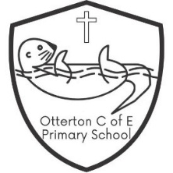
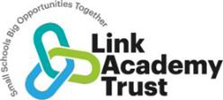
Otterton C of E Primary
RE and Worldviews Curriculum Statement

RE is an exciting forum for the children to feel engaged, inspired and challenged. Through RE we aim to prepare our children to become global citizens who can discern and articulate their own informed worldviews with empathy and compassion. We want them to develop their capacity to reflect on personal ideas and beliefs and begin to understand where this sits in relation to other worldviews. We feel passionate about delivering an RE curriculum which promotes the virtues of respect and empathy, which are so important in our diverse society. It fosters civilised debate and reasoned argument, and through developing this religious literacy, ultimately helps our children to understand the place of religion and belief in the modern world.

Our values and distinct Christian ethos of the school, creates a kind, caring, inclusive environment in which children have the confidence to consider the big questions in life, to discover what people believe and how this makes a difference to their lives. Through gaining the knowledge, understanding and skills to handle these questions, children can reflect on their own ideas and ways of living. By deepening their understanding of the beliefs and practices of others, the children’s own ideas are set in a wider context and underpinned by their developing sense of morality.

Vocabulary
Children’s command of vocabulary is fundamental to learning and progress across the curriculum. Vocabulary is developed actively, building systematically on pupil’s current knowledge and deepening their understanding of etymology and morphology (word origins and structures) to increase their store of words. Simultaneously, pupils make links between known and new vocabulary, and discuss and apply shades of meaning. In this way, children expand the vocabulary choices that are available to them. It is essential to introduce technical vocabulary which define each curriculum subject. Vocabulary development is underpinned by an oracy culture and a tiered approach. High value is placed on the conscious, purposeful selection of well-chosen vocabulary and appropriate sentence structure to enrich access to learning and feed into written work across the curriculum.

A rich vocabulary: thinking and talking like an expert…
We want children to understand and make connections between, religious and non-religious beliefs, concepts, practices and ideas. To do this, they need the correct language to articulate their thoughts. The words below give an indication of the language used in class to ensure that children can talk like an expert.
Christianity
Key Stage 1 Key vocabulary
Advent, baptism, believer, Bible, Christ, Christmas, Church, Creation, Disciple, Easter, Faith, God, Harvest, Holy, Hymn, Jesus, Prayer, Priest, Vicar, Worship.
Key Stage 2 Lower Key vocabulary
Advent, Baptism, Bible, Christ, Christmas, Church, Creation, Disciple, Easter, Faith, follower, God, Gospel, Harvest, Holy, Hymn, Jesus, Lent, New Testament, Old Testament, Parables, Pentecost, Prayer, Priest, Prophet, Ten Commandments, Vicar, Worship.
Key Stage 2 Upper Key vocabulary
Advent, Ascension, Baptism, Bible, Christ, Christmas, Church, Creation, Disciple, Easter, Faith, God, Gospel, Grace, Harvest, Holy, Holy Communion, Holy Spirit, Hymn, Incarnation, Jesus, Lent, Lord’s Prayer, Lord’s Supper, Mass, Miracle, Monotheistic, Myth, New Testament, Old Testament, Parables, Pentecost, Practice, Prayer, Priest, Prophet, Psalm, Resurrection, Saint, Salvation, Sin, Soul, Ten Commandments, Trinity, Vicar, Worship.
Hinduism
Key Stage 2 Key vocabulary
Aum or Om, Brahman, Diwali, Ganesh, Gods and goddesses, Hindu, Hinduism, Mandir, Offering, Pray, Rama, Shiva, Shrine, Sita, Vishnu, Worship
Humanism
Key Stage 1 Key vocabulary
Celebrant, Happy Human, Humanism, Humanist, Science, The Golden Rule.
Key Stage 2 Key vocabulary
Agnosticism, Atheism, Atheist, Celebrant, Compassion, Curiosity, Dignity, Empathy, Evidence, Evolution, Flourishing, Happy Human, Human rights, Humanism, Humanist, Humanity, Natural selection, Reason, Respect, Responsibility, Science, The Big Bang, The Golden Rule.
Islam
Key Stage 1 Key vocabulary
Allah, Islam, Mosque, Muslim, Prophet, Quran.
Key Stage 2 Key vocabulary
Allah, Hajj, Islam, Mihrab, Mosque, Muslim, Prophet, Qiblah, Quran, Salaa, Sawm, Shahada.
Judaism
Key Stage 1 Key vocabulary
Synagogue: Ark, Kippah, Tallit, Torah Scrolls, Yad,
Shabbat: Kosher Two Candles, Challah, Wine,
Jewish Life: Chanukah, Covenant, Dreidel, Maccabees, One God (YHVH), Purim, Rosh Hashanah, Shofar.
Key Stage 2 Key vocabulary
Synagogue: Ark, Bimah, Kippah, Menorah (Chanukiah), Ner Tamid (Eternal Light), Star of David, Rabbi, Tallit, Torah Scrolls, Yad.
Shabbat: Besamim (Spices), Challah, Havdalah, Havdalah candle, Kiddush Cup (goblet), Kosher, Two Candles, Wine.
Jewish Life: 5 Books of Moses(Chumash), 24 Books of the written Torah, 613 Commandments, Bar Mitzvah/Bat Mitzvah, Chanukah, Covenant, Dreidel, Egypt, King David Maccabees, Matzah, Messiah, Moses, One God (YHVH), Patriarchs (Abraham, Isaac, Jacob), Pesach, Purim, Rosh Hashanah, Shofar,Sukkah (Booth), Yom Kippur.

The Devon and Torbay Agreed Syllabus for RE 2024-29
RE has an important part to play as part of a broad, balanced, and coherent curriculum to which all pupils are entitled. High quality learning experiences in RE are designed and provided by careful planning through the Locally Agreed Syllabus, using Understanding Christianity and RE Today units. Our spiral curriculum focuses on depth rather than breadth, exploring the lives and beliefs of Christians, Jews, Hindus and Muslims through systemic units (studying one religion at a time) and then thematic units, which may cover other religious or non-religious worldviews and build on learning by comparing the beliefs and practices studied. Exploring the same concepts again, from a different perspective and using different materials, is essential to support pupils’ ability to connect ideas and develop a coherent understanding of religion and belief, consolidating and embedding learning.
An enquiry-based approach is taken and each half termly unit of work begins with an enquiry question that is explored through three strands: making sense of belief, making connections and understanding the impact. The model below shows how the three strands of this teaching and learning model interrelate to each other.
We have adopted the use of worldviews as a way of allowing for some flexibility in the presentation of traditional religions – acknowledging the diversity within traditions, geographically and across time. This approach also enables pupils to recognise that members of religious traditions may have individual worldviews that differ. The idea of personal worldviews also includes the pupils’ own perspectives within the RE classroom.

We have embraced the language of ‘knowledge in RE’, as identified in OFSTED’s RE Research Review. The three kinds being:
- Substantive knowledge - the subject content being studied, in terms of the core concepts, truth claims, teachings and practices, (covered by the Beliefs and Impact strands)
- Ways of knowing - This includes the methods used to establish the substantive knowledge. Also known as ‘disciplinary knowledge’, to illustrate the use of academic disciplines to examine content, such as theology, philosophy or sociology. (see diagram below)
- Personal knowledge - This includes the personal perspective or worldview of the pupil. It enables pupils to better understand and examine their own position, assumptions and values, (covered in the Making connections strand)

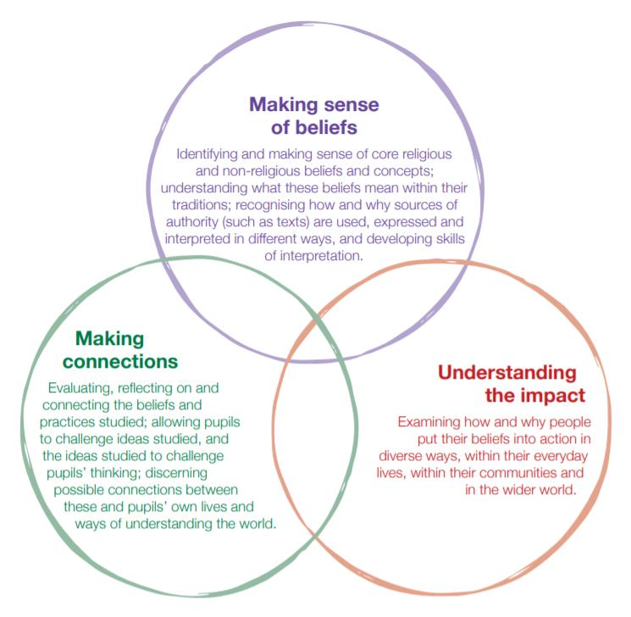

The three key disciplinary areas are expanded on here, and although they are not highlighted under these headings in our current RE Agreed Syllabus, they are implied through the strands of its teaching and learning model (shown above). This enables teachers to draw on different methods from a range of disciplines, including others not highlighted here, within the units they teach.

Here is our 4 year rolling programme
Year A | Autumn 1 | Spring 1 | Summer 1
Reception | Being special: where do we belong?  F2 INCARNATION: Why do Christians perform Nativity play at Christmas? | What time / stories are special and why?  F3 SALVATION: Why do Christians put a cross in an Easter garden? | F1 GOD/ CREATION: Why is the word ‘God’ so important to Christians?  What places are special and why?
Years  1 & 2 | Who is Muslim and how do they live (part 1)  1.3 INCARNATION: Why does Christmas matter to Christians? | Who is Muslim and how do they live (part 2)  1.5 SALVATION: Why does Easter matter to Christians? | 1.4 GOPSEL: What is the good news Jesus brings?  What makes some places sacred to believers?
Years  3 & 4 | 2a.4 GOSPEL: What kind of world did Jesus want? (3/4)  2B.4 INCARNATION was Jesus the Messiah?  Christmas (5/6) | How do festivals and family life show what matters to Jewish people? (3/4)  2a.2 PEOPLE OF GOD: What is it like to follow God? (3/4) | Why is the Torah so important to Jewish people? (5/6)  New – U2.11 – What does it mean to be a humanist in Britain today?
Years
5 & 6

Year B | Autumn 1 | Spring 1 | Summer 1
Reception | Being special: where do we belong?  F2 INCARNATION: Why do Christians perform Nativity play at Christmas? | What time / stories are special and why?  - F3 SALVATION: Why do Christians put a cross in an Easter garden? | F1 GOD/ CREATION: Why is the word ‘God’ so important to Christians?  What places are special and why?
Years  1 & 2 | 1.2 CREATION: Who made the world?  Harvest.  What does it mean to belong to a faith community? | 1.1GOD: What do Christians believe God is like?  Who is Jewish and how do they live (part 1) | Who is Jewish and how do they live (part 2)  1.9 - How should we care for the world and for others, and why does it matter?
Years  3 & | Why do Hindus want to be good? (yr 5)  2a.3 INCARNATION / GOD: What is the Trinity? (yr 4)  Christmas | 2b.2 CREATION/FALL: Creation and science – conflict or complimentary? (yr 5)  New – U2.13 – What can be done to reduce racism? Can religion help? | 2b.8 KINGDOM OF GOD: What kind of king is Jesus? (yr 5)  Why do some people think that life is like a journey and what significant events mark this? (yr 4)
Years
5 & 6

Year C | Autumn 1 | Spring 1 | Summer 1
Reception | Being special: where do we belong?  F2 INCARNATION: Why do Christians perform Nativity play at Christmas? | What time / stories are special and why?  F3 SALVATION: Why do Christians put a cross in an Easter garden? | F1 GOD/ CREATION: Why is the word ‘God’ so important to Christians?  What places are special and why?
Years  1 & 2 | Who is Muslim and how do they live (part 1)  1.3 INCARNATION: Why does Christmas matter to Christians? | Who is Muslim and how do they live (part 2)  1.5 SALVATION: Why does Easter matter to Christians? | 1.4 GOPSEL: What is the good news Jesus brings?  What makes some places sacred to believers?
Years  3 & 4 | 2a.1: CREATION/ FALL: What do Christians learn from the creation story? (3/4)  What does it mean to be a Muslim in Britain today? (5/6) | How do festivals and worship show what matters to a Muslim? (3/4)  Easter | How and why do religious and non-religious people try to make the world a better place? (3/4)  What matters most to Humanists and Christians? (5/6)
Years
5 & 6

Year D | Autumn 1 | Spring 1 | Summer 1
Reception | Being special: where do we belong?  F2 INCARNATION: Why do Christians perform Nativity play at Christmas? | What time / stories are special and why?  F3 SALVATION: Why do Christians put a cross in an Easter garden? | F1 GOD/ CREATION: Why is the word ‘God’ so important to Christians?  What places are special and why?
Years  1 & 2 | 1.2 CREATION: Who made the world?  Harvest.  What does it mean to belong to a faith community? | - GOD: What do Christians believe God is like?  Who is Jewish and how do they live (part 1) | Who is Jewish and how do they live (part 2)  1.9 - How should we care for the world and for others, and why does it matter?
Years  3 & 4 | What do Hindus believe God is like? (3/4)  What does it mean to be a Hindu in Britain today? (3/4) | NEW L2.13 - How do people from religious and non-religious communities celebrate key festivals?  2b.1 GOD: What does it mean if God is Holy and loving? (5/6) | New U2.14 – what do religious and non-religious worldviews teach about caring for the Earth  2b.5 GOSPEL: What would Jesus do? (5/6)
Years
5 & 6

Core concepts and key enquiry questions – an overview

 |  |  |  | FS (Discovering) |  | KS1 (Exploring) |  | Lower KS2 (Connecting) |  | Upper KS2 (Connecting) |  | KS3 (Applying/Interpreting)
 | Religion/belief |  |  | Christianity plus others |  | Christians, Jews and  Muslims |  | Christians, Muslims, Hindus and Jews |  |  |  | Christians, Muslims, Buddhists, Sikhs
 |  |  |  |  |  | 1.1 What do Christians  believe God is like? [God]  1.2 Who do Christians say  made the world? [Creation]  1.3 Why does Christmas  matter to Christians?  (Incarnation)  1.4 What is the ‘good news’  Christians believe Jesus  brings? [Gospel]  1.5 Why does Easter matter to Christians? [Salvation] |  | L2.1 What do Christians learn from the creation story? [Creation/Fall]  L2.2 What is it like for someone to follow God? [People of God]  L2.3 What is the ‘Trinity’ and why  is it important for Christians? [God/  Incarnation]  L2.4 What kind of world did Jesus  want? [Gospel]  L2.5 Why do Christians call the day  Jesus died ‘Good Friday’?  [Salvation]  L2.6 For Christians, what was the  impact of Pentecost? [Kingdom of  God] |  | U2.1 What does it mean if Christians  believe God is holy and loving?[God]  U2.2 Creation and science: conflicting or complementary? [Creation]  U2.3 Why do Christians believe Jesus was the Messiah? [Incarnation]  U2.4 How do Christians decide how to live? ‘What would Jesus do?’ [Gospel]  U2.5 What do Christians believe Jesus did to ‘save’ people? [Salvation]  U2.6 For Christians, what kind of king is Jesus? [Kingdom of God] |  | 3.1 What does it mean for Christians to believe in God as Trinity? [God]  3.2 Should Christians be greener than everyone else? [Creation]  3.3 Why are people good and bad? [Fall]  3.4 Does the world need prophets today? [People of God]  3.5 What do people do when life gets hard?  [Wisdom]  3.6 Why do Christians believe Jesus was God on Earth? [Incarnation]  3.7 What is so radical about Jesus? [Gospel]
 | Christianity  God  Creation  Fall  People of God  Incarnation  Gospel  Salvation  Kingdom of God |  |  | F1 Why is the word  ‘God’ so important to  Christians? [God]  F2 Why is Christmas  special for Christians?  [Incarnation]  F3 Why is Easter special  for Christians? [Salvation]
 | Buddhism  Buddha  Dhamma  Sangha |  |  |  |  |  |  |  |  |  |  | 3.8 The Buddha: how and why do his experiences and teachings have meaning for people today? [Buddha/dhamma/sangha]
 | The Hindu Traditions  Samsara and moksha  Brahman (God) and  atman  Karma and dharma |  |  |  |  |  |  | L2.7 What do Hindus believe God is  like? [Brahman/atman]  L2.8 What does it mean to be Hindu inBritain today? [Dharma] |  | U2.7 Why do Hindus want to be  good? [Karma/dharma/samsara/  moksha] |  | 3.9 Why don’t Hindus want to be reincarnated  and what do they do about it? [Samsara/moksha/atman/karma/dharma]
 | Islam  God/Tawhid  Iman (faith)  Ibadah (worship)  Akhirah (life after death)  Akhlaq (virtue/morality) |  |  |  |  | 1.6 Who is a Muslim and  how do they live? [God/  Tawhid/ibadah/iman] |  | L2.9 How do festivals and worship  show what matters to a Muslim?  [Ibadah] |  | U2.8 What does it mean to be a  Muslim in Britain today?  [Tawhid/iman/ibadah] |  | 3.10 What is good and what is challenging about being a Muslim teenager in Britain today? [Iman/ibadah/akhlaq]
Religion/belief |  |  | FS (Discovering) |  | KS1 (Exploring) |  | Lower KS2 (Connecting) |  | Upper KS2 (Connecting) |  | KS3 (Applying/Interpreting)
Judaism  God  Torah  The People and  the Land |  |  |  |  | 1.7 Who is Jewish and how do they live? [God/Torah/  People] |  | L2.10 How do festivals and family life show what matters to Jewish people?  [God/Torah/People/the Land] |  | U2.9 Why is the Torah so important to Jewish people? [God/Torah] |  | 3.11 What is good and what is challenging about  being a Jewish teenager in Britain today? [People and the Land]
Sikhi  God  Values (Nam Simran,  kirat karna, vand  chhakna, seva)  The Gurus  Panth (community) |  |  |  |  |  |  |  |  |  |  | 3.12 How are Sikh teachings on equality and  service put into practice today? [God/the Gurus/  values/Panth]
Non-religious  worldviews |  |  |  |  |  |  |  |  | U2.11b What does it mean to be a  Humanist in Britain today? |  | 3.13 What difference does it make to be non-  religious in Britain today?
Thematic |  |  | F4 Being special: where  do we belong?  F5 Which places are  special and why?  F6 Which stories are  special and why? |  | 1.8 What makes some  places sacred to believers?  1.9 How should we care for others and the world, and why does it matter?  1.10 What does it mean to  belong to a faith or belief  community? |  | L2.11 How and why do people mark  the significant events of life?  L2.12 How and why do people try to  make the world a better place?  L2.13a How do people from religious  and non-religious communities  celebrate key festivals? |  | U2.10 What matters most to  Humanists and Christians?  U2.12 How does faith help when life gets hard?  U2.13c What can be done to reduce  racism? Can religion help?  U2.14c What do religious and non-  religious worldviews teach about  caring for the Earth? |  | 3.14 Good, bad; right, wrong: how do I decide?  3.15 How far does it make a difference if you  believe in life after death?  3.16 Why is there suffering? Are there any good  solutions?  3.17 Should happiness be the purpose of life?  3.18 How can people express the spiritual through the arts?
RE and Worldviews in the Early Years Foundation Stage
RE sits very firmly within the areas of ‘Personal, Social and Emotional Development’ and ‘Understanding of the World’. From an early age, the children at our school learn to develop a positive sense of themselves, and others, and learn how to form positive and respectful relationships as part of their growing sense of self, of their own community and their place within it. They will be supported in this through encountering religious and non-religious worldwide views through special people, books, places and objects and by visiting places of worship. The children will have the opportunity to listen to and talk about stories. They are introduced to subject-specific words and use all of their senses to explore beliefs, practices and forms of expression. In the Early Years, the children ask questions and reflect on their own feelings and experiences. They use their imaginations and curiosity to develop their appreciation of, and wonder at, the world in which they live.
See page 31 of Agreed Syllabus for more detail on opportunities for RE across the EYFS Profile prime and specific areas.
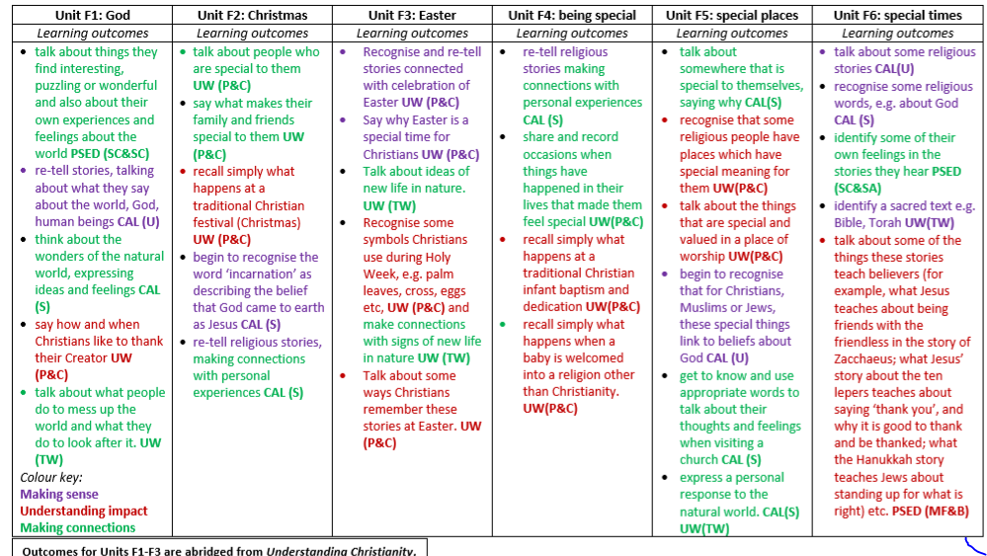

Progression of key knowledge, skills and understanding - KS1/2
End of phase outcomes taken from the 2024 Agreed Syllabus

Teaching and learning approach | End KS1 | End lower KS2 | End upper KS2 | End KS3
Element 1:  Making sense of beliefs | Pupils can … | Pupils can … | Pupils can … | Pupils can …
Element 1:  Making sense of beliefs | • identify core beliefs and concepts  studied and give a simple description of what they mean  • give examples of how stories show  what people believe (e.g. the meaning behind a festival)  • give clear, simple accounts of what  stories and other texts mean to  believers | • identify and describe the core beliefs  and concepts studied  • make clear links between texts/  sources of authority and the core  concepts studied  • offer informed suggestions about what  texts/sources of authority can mean  and give examples of what these  sources mean to believers | • identify and explain the core beliefs  and concepts studied, using examples from texts/sources of authority in religions  • describe examples of ways in which  people use texts/sources of authority to make sense of core beliefs and concepts  • give meanings for texts/sources of  authority studied, comparing these  ideas with some ways in which  believers interpret texts/sources  of authority | • give reasoned explanations of how  and why the selected core beliefs and concepts are important within the religions studied  • taking account of context(s), explain  how and why people use and make  sense of texts/sources of authority  differently  • in the light of their learning,  explain how appropriate different  interpretations of texts/sources of  authority are, including their own ideas
Identifying and making sense of religious and non-religious beliefs and concepts; understanding what these beliefs mean within their traditions; recognising how and why sources of authority (such as texts) are used, expressed and interpreted in different ways, and developing skills of interpretation.
Element 2:  Understanding the impact | • give examples of how people use  stories, texts and teachings to guide  their beliefs and actions  • give examples of ways in which  believers put their beliefs into practice | • make simple links between stories,  teachings and concepts studied and  how people live, individually and in  communities  • describe how people show their beliefs in how they worship and in the way they live  • identify some differences in how  people put their beliefs into practice | • make clear connections between  what people believe and how they live, individually and in communities  • using evidence and examples, show  how and why people put their beliefs  into practice in different ways, e.g. in  different communities, denominations or cultures | • give reasons and examples to account for how and why people put their beliefs into practice in different ways, individually and in various communities (e.g. denominations, times or cultures; faith or other communities)  • show how beliefs guide people in  making moral and religious decisions applying these ideas to situations in the world today
Examining how and why people put their beliefs into practice in diverse ways, within their everyday lives, within their communities and in the wider world.
Element 3:  Making connections | • think, talk and ask questions about  whether the ideas they have been  studying, have something to say  to them  • give a good reason for the views they  have and the connections they make | • make links between some of the  beliefs and practices studied and life  in the world today, expressing some  ideas of their own clearly  • raise important questions and suggest  answers about how far the beliefs  and practices studied might make a  difference to how pupils think and live  • give good reasons for the views they  have and the connections they make | • make connections between the beliefs  and practices studied, evaluating and  explaining their importance to different  people (e.g. believers and atheists)  • reflect on and articulate lessons  people might gain from the beliefs/  practices studied, including their own  responses, recognising that others  may think differently  • consider and weigh up how ideas  studied in this unit relate to their own  experiences and experiences of the  world today, developing insights of  their own and giving good reasons  for the views they have and the  connections they make | • give coherent accounts of the  significance and implications of the  beliefs and practices studied in the  world today  • evaluate how far the beliefs and  practices studied help pupils  themselves and others to make sense of the world  • respond to the challenges raised by questions of belief and practice, both in the world today and in their own lives, offering reasons and justifications for their responses
Evaluating, reflecting on and connecting
the beliefs and practices studied; allowing pupils to challenge ideas studied, and the ideas studied to challenge pupils’ thinking; discerning possible connections between these and pupils’ own lives and ways of
understanding the world.
Implementation

Otterton C of E Primary school has a well-embedded Christian vision which is at the core of our learning. The children believe that they can flourish and achieve, implementing our values throughout our school and community.
The children across the school are offered visits and experiences to enrich their learning and bring other cultures and traditions to life. For example, the KS1 children had a wonderful, reflective visit to the Mosque and the KS2 children welcomed a Hindu family in to share their beliefs and traditions.
They are given opportunities to build links and with their own schools and local community and nurture their sense of belonging. We have strong links with the local residential home, shops, and community.
Our schools have well established links with our local churches which we visit weekly. The children are all very fond of the open the book team and enjoy taking active roles in helping to act out stories from the bible. Our schools have a close relationship with the vicar who plays an integral role in key events across the school year. He helps provide a direct link with the local community and also takes an active role in our adult ethos group. As part of our core offer, we provide whole school enrichment opportunities, which enable children to experience events linked to the church calendar: Harvest, Christmas Nativities, Mothering Sunday, Easter and leavers services.
Teachers link with key dates and religious festivals, providing opportunities to celebrate festivals and religions with greater relevance and consistency which enhances a cross-curricular approach. Collective worships play a big role in exploring these festivals giving children across the school the chance to question and reflect.
We have an ethos group made up of children across the school which meet regularly to discuss aspects of our school commitment to our vision, to work on the value for each term and to review and develop the effectiveness of our collective worships. The children are very proactive in raising money for charities, caring for the local community and thinking of ways to be advocates of change.
Teachers strive to ensure that all children have a passion for learning about religion and are educated to develop emotionally, academically, morally, and spiritually. This enables and inspires children to grow as confident, independent learners, fully equipped and ready for life’s challenges of living in a swiftly changing world. We encourage our pupils to look at their own world, thinking about who they are and what makes them go wow. They then take time to reflect and act on their thoughts and reflections.
At the beginning of each lesson, the use of questioning helps with the children’s recall of key information, vocabulary and to organise their knowledge.
A focus on QFT (Quality First Teaching) ensures that we have high expectations and that all children are supported, when appropriate, to access our full and rich RE curriculum.
RE makes an important contribution to other aspects of children’s learning by providing opportunities for promoting Fundamental British Values, developing SMSC and supporting their personal development and mental wellbeing. Links are also made with other curricular areas.
Learning is not always recorded/captured in a formal written way. Children are given the opportunity to use discussion, drama and art to interpret and present their understanding in different ways. Evidence of learning can be found in RE workbooks or class scrapbooks. Our curriculum time for RE is distinct from the time spent on collective worship although we make links between the collective worship and the purposes and themes of RE as appropriate. All RE units are taught discretely each week.

EYFS - 36 hours of RE
(e.g. 50 minutes a week or some short sessions implemented through continuous provision)
KS1  36 hours of tuition per year  (e.g. An hour a week, or less than an hour a week plus a series of RE days) | KS2  45 hours of tuition per year  (e.g. An hour a week, or a series of RE days or weeks amounting to 45+ hours of RE)
Christians, Jews and Muslims | Christians, Muslims, Hindus and Jews
Consideration of other religions and nonreligious worldviews can occur at any key stage, as appropriate to the school context.

To assess impact
In line with the school policy on assessment and recording it is expected that each teacher will be responsible for the regular assessment of their pupils to judge the impact of teaching and learning in RE. Getting better at RE means knowing more, remembering more (receptive expertise) and therefore being able to ‘do’ more in RE (productive expertise).
Teachers look at the learning journey of each unit studied, being aware of what the children need for their next learning and what they can take from prior learning. A unit will begin with an elicitation task, either individual or whole class, to judge the level of prior knowledge. End of phase outcomes from the Agreed Syllabus represent progress in relation to knowledge, understanding and skills. Teachers use the specific learning outcomes in each unit to plan content and assess progress and these relate directly to the end of phase outcomes.
Ongoing assessment for learning informs teaching and learning within the unit, using a variety of methods, ie listen, watch, quiz, question, check for misconceptions etc.
Children’s progress is also monitored using end of unit summative comments/’I can’ statements, under the headings of Emerging/Developing Independence, Secure and Greater Depth. Judgement is informed through using dialogue, observations, class scrapbooks and children’s books. Teachers need to be clear on how the children will show their learning, through a presentation, art work or extended writing for example, providing opportunity for pupils communicate their learning in a variety of ways. Not all will be able to show their best achievement through writing or art or discussion, so over time there needs to be a rich diet of forms of communication. Likewise, all the skills in RE need to be used and developed, so employing creative assessment tasks which draw on a range of these skills is essential.
Monitoring of R.E. consists of: book scrutiny, assessment information and pupil conferencing which occur regularly as part of our monitoring cycle (Ethos Group monitoring in C of E sch), together with learning walks and lesson observations.

